# Test 4
# que 1
def factorsOfN(n):
print("Factors of",n, "=", end = " ")
for i in range(1,n+1):
if(n%i==0):
print(i, end = " ")
print()
n = int(input("Enter number = "))
factorsOfN(n)
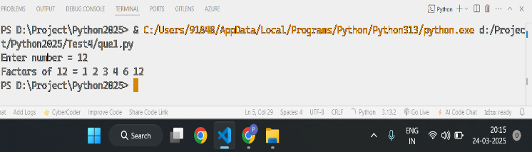

# que 2
def factorial(i,num,fact):
if(i<=num):
fact=fact*i
i=i+1
return factorial(i,num,fact)
else:
return fact
num = int(input("Enter number : "))
res1 = factorial(1,num,1)
print("factorial of ",num,"=",res1)
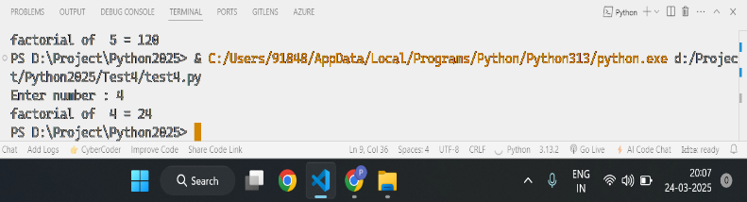

# que 3
n = int(input("Enter number to print pattern z = "))
for i in range(n):
for j in range(n):
if( i == 0 or i == n-1 or j == (n-i-1) ):
print("*", end=" ")
else:
print(" ",end=" ")
print()
